- Steps I had to do to configure the environment:
- Change the Python Interpreter in VS Code:
- Open the VS Code Command Palette using Ctrl + Shift + P.
- Type and select: Python: Select Interpreter.
- Choose global Python installation
- py -m pip install pandas
- py -m pip install seaborn
- Fix Code Runner:
- Open VS Code Settings by pressing Ctrl + ,
- In the search bar at the top, type: executor map.
- Edit in settings.json.
- “python": "python -u"
- Change it to use the py launcher: JSON, change “python": "python -u"
to "python": "py -u"
- py -m pip install openpyxl
- Data inspection
function | meaning
df.shape | Number of rows and columns. The expected dataset in our project context is approximately 79,330 rows and 31 columns; verify this against your actual file.
df.columns | Which variables are available to us.
df.head() | Whether the data looks correctly loaded and what its values look like.
df.dtypes | Whether columns are numeric, text, or another type.
df.isna().sum() | Which columns contain missing values and how many.
df.duplicated().sum() | Whether complete rows are repeated. This flags candidates for investigation, not automatic deletion.
df.describe() | Numerical ranges, averages, standard deviations, and quartiles.
df["ADR"].describe() | The distribution's basic statistics for the variable we want to predict.
We run inspection.py
• Removed na_values from read_excel() so we can handle whitespace-padded placeholders consistently ourselves.
• Stripped whitespace first, converting " NULL" into "NULL".
• Replaced the exact null-like strings with pd.NA, avoiding the overly broad regular expression from the previous version.
• Kept all original inspection sections and added verification for Agent and Company.
output:
Original shape: (79330, 31)

--- Dataset Overview ---
Dataset shape: (79330, 31)

Column names:
['IsCanceled', 'LeadTime', 'ArrivalDateYear', 'ArrivalDateMonth', 'ArrivalDateWeekNumber', 'ArrivalDateDayOfMonth', 'StaysInWeekendNights', 'StaysInWeekNights', 'Adults', 'Children', 'Babies', 'Meal', 'Country', 'MarketSegment', 'DistributionChannel', 'IsRepeatedGuest', 'PreviousCancellations', 'PreviousBookingsNotCanceled', 'ReservedRoomType', 'AssignedRoomType', 'BookingChanges', 'DepositType', 'Agent', 'Company', 'DaysInWaitingList', 'CustomerType', 'ADR', 'RequiredCarParkingSpaces', 'TotalOfSpecialRequests', 'ReservationStatus', 'ReservationStatusDate']

First five rows:
IsCanceled LeadTime ... ReservationStatus ReservationStatusDate
0 0 6 ... Check-Out 2015-07-03
1 1 88 ... Canceled 2015-07-01
2 1 65 ... Canceled 2015-04-30
3 1 92 ... Canceled 2015-06-23
4 1 100 ... Canceled 2015-04-02

[5 rows x 31 columns]

Data types:
IsCanceled int64
LeadTime int64
ArrivalDateYear int64
ArrivalDateMonth string
ArrivalDateWeekNumber int64
ArrivalDateDayOfMonth int64
StaysInWeekendNights int64
StaysInWeekNights int64
Adults int64
Children float64
Babies int64
Meal string
Country string
MarketSegment string
DistributionChannel string
IsRepeatedGuest int64
PreviousCancellations int64
PreviousBookingsNotCanceled int64
ReservedRoomType string
AssignedRoomType string
BookingChanges int64
DepositType string
Agent string
Company string
DaysInWaitingList int64
CustomerType string
ADR float64
RequiredCarParkingSpaces int64
TotalOfSpecialRequests int64
ReservationStatus string
ReservationStatusDate datetime64[us]
dtype: object

--- Missing Values ---
Company 75641
Agent 8131
Country 24
Children 4
ArrivalDateWeekNumber 0
ArrivalDateMonth 0
IsCanceled 0
StaysInWeekendNights 0
ArrivalDateDayOfMonth 0
Adults 0
StaysInWeekNights 0
Babies 0
Meal 0
LeadTime 0
ArrivalDateYear 0
DistributionChannel 0
MarketSegment 0
PreviousBookingsNotCanceled 0
IsRepeatedGuest 0
ReservedRoomType 0
AssignedRoomType 0
BookingChanges 0
PreviousCancellations 0
DepositType 0
DaysInWaitingList 0
CustomerType 0
ADR 0
RequiredCarParkingSpaces 0
TotalOfSpecialRequests 0
ReservationStatus 0
ReservationStatusDate 0
dtype: int64

Total missing cells: 83800

Missing ADR values: 0

Agent:
Missing values: 8131
Non-missing values: 71199
Missing percentage: 10.25 %
Most common values:
Agent
9 31955
<NA> 8131
1 7137
14 3640
7 3539
6 2683
28 1666
3 1308
8 1236
37 1230
19 1061
21 875
229 786
83 696
29 679
Name: count, dtype: Int64

Company:
Missing values: 75641
Non-missing values: 3689
Missing percentage: 95.35 %
Most common values:
Company
<NA> 75641
40 924
67 267
45 250
153 215
219 141
233 114
174 113
51 86
242 61
348 59
38 51
91 48
280 48
197 47
Name: count, dtype: Int64

--- Exact Duplicates ---
Original rows: 79330
Duplicate occurrences: 25902
Rows after dropping exact duplicates: 53428

--- Numerical Summary ---
IsCanceled ... ReservationStatusDate
count 79330.000000 ... 79330
mean 0.417270 ... 2016-07-30 17:43:49.048279
min 0.000000 ... 2014-10-17 00:00:00
25% 0.000000 ... 2016-02-05 00:00:00
50% 0.000000 ... 2016-08-10 00:00:00
75% 1.000000 ... 2017-02-06 00:00:00
max 1.000000 ... 2017-09-07 00:00:00
std 0.493111 ... NaN

[8 rows x 19 columns]

--- ADR Summary ---
count 79330.000000
mean 105.304465
std 43.602954
min 0.000000
25% 79.200000
50% 99.900000
75% 126.000000
max 5400.000000
Name: ADR, dtype: float64

ADR percentiles:
0.00 0.0
0.01 0.0
0.25 79.2
0.50 99.9
0.75 126.0
0.95 175.5
0.99 228.0
1.00 5400.0
Name: ADR, dtype: float64

--- Negative Values ---
Zero ADR values: 1208
Negative ADR values: 0

--- Binary Variables ---

IsCanceled values:
IsCanceled
0 46228
1 33102
Name: count, dtype: int64

IsRepeatedGuest values:
IsRepeatedGuest
0 77298
1 2032
Name: count, dtype: int64

--- Arrival Dates ---

Arrival years:
ArrivalDateYear
2015 13682
2016 38140
2017 27508
Name: count, dtype: int64

Arrival months:
ArrivalDateMonth
August 8983
May 8232
July 8088
June 7894
October 7605
April 7480
September 7400
March 6458
February 4965
November 4357
December 4132
January 3736
Name: count, dtype: Int64

Arrival day range:
1 31

--- Guest Counts ---
Bookings with zero adults, children and babies: 167

Bookings with zero adults: 390

Zero-adult bookings by ADR:
count 390.000000
mean 51.165846
std 49.143557
min 0.000000
25% 0.000000
50% 66.825000
75% 91.850000
max 200.000000
Name: ADR, dtype: float64

Examples of zero-adult bookings:
Adults Children Babies ADR StaysInWeekendNights StaysInWeekNights IsCanceled CustomerType ReservationStatus
0 0.0 0 0.00 2 5 0 Transient-Party Check-Out
0 0.0 0 0.00 2 0 0 Contract Check-Out
0 3.0 0 9.00 1 1 0 Transient-Party Check-Out
0 0.0 0 0.00 9 20 0 Transient Check-Out
0 2.0 0 6.00 0 3 0 Transient-Party Check-Out
0 0.0 0 0.00 0 4 0 Transient-Party Check-Out
0 2.0 0 6.00 2 0 0 Transient-Party Check-Out
0 2.0 0 0.00 0 1 0 Transient Check-Out
0 0.0 0 0.00 2 0 1 Transient-Party Canceled
0 0.0 0 0.00 1 4 0 Transient Check-Out
0 0.0 0 0.00 0 2 0 Transient Check-Out
0 0.0 0 0.00 0 1 0 Transient Check-Out
0 2.0 0 6.00 1 3 1 Transient-Party Canceled
0 3.0 0 104.25 1 0 1 Transient-Party Canceled
0 2.0 1 77.00 0 1 0 Transient-Party Check-Out

--- ADR Investigation ---
IQR lower bound: 9.000000000000014
IQR upper bound: 196.2
ADR below lower bound: 1316
ADR above upper bound: 2071

Record with the highest ADR:
IsCanceled 1
LeadTime 35
ArrivalDateYear 2016
ArrivalDateMonth March
ArrivalDateWeekNumber 13
ArrivalDateDayOfMonth 25
StaysInWeekendNights 0
StaysInWeekNights 1
Adults 2
Children 0.0
Babies 0
Meal BB
Country PRT
MarketSegment Offline TA/TO
DistributionChannel TA/TO
IsRepeatedGuest 0
PreviousCancellations 0
PreviousBookingsNotCanceled 0
ReservedRoomType A
AssignedRoomType A
BookingChanges 1
DepositType Non Refund
Agent 12
Company <NA>
DaysInWaitingList 0
CustomerType Transient
ADR 5400.0
RequiredCarParkingSpaces 0
TotalOfSpecialRequests 0
ReservationStatus Canceled
ReservationStatusDate 2016-02-19 00:00:00

Examples of zero-ADR bookings:
ADR Adults Children Babies LeadTime StaysInWeekendNights StaysInWeekNights CustomerType MarketSegment ReservedRoomType ReservationStatus
0.0 1 0.0 0 6 0 2 Transient Offline TA/TO A Check-Out
0.0 2 0.0 0 0 0 1 Transient Direct A Canceled
0.0 2 0.0 0 0 2 5 Transient Direct F Check-Out
0.0 1 0.0 0 18 1 1 Transient-Party Groups A Check-Out
0.0 1 0.0 0 12 2 2 Transient-Party Groups A Check-Out
0.0 1 0.0 0 12 2 2 Transient-Party Groups A Check-Out
0.0 1 0.0 0 20 0 2 Transient-Party Groups A Check-Out
0.0 1 0.0 0 20 0 2 Transient-Party Groups A Check-Out
0.0 1 0.0 0 132 0 1 Transient-Party Groups A Check-Out
0.0 1 0.0 0 132 0 1 Transient-Party Groups A Check-Out

Bookings with ADR below 9:
Count: 1306
ADR Adults Children Babies CustomerType MarketSegment ReservationStatus
0.0 1 0.0 0 Transient Offline TA/TO Check-Out
0.0 2 0.0 0 Transient Direct Canceled
0.0 2 0.0 0 Transient Direct Check-Out
0.0 1 0.0 0 Transient-Party Groups Check-Out
0.0 1 0.0 0 Transient-Party Groups Check-Out
0.0 1 0.0 0 Transient-Party Groups Check-Out
0.0 1 0.0 0 Transient-Party Groups Check-Out
0.0 1 0.0 0 Transient-Party Groups Check-Out
0.0 1 0.0 0 Transient-Party Groups Check-Out
0.0 1 0.0 0 Transient-Party Groups Check-Out
0.0 0 0.0 0 Transient-Party Groups Check-Out
0.0 2 0.0 0 Transient Direct Check-Out
0.0 2 1.0 0 Transient Direct Check-Out
0.0 2 1.0 0 Transient Direct Check-Out
0.0 1 0.0 0 Transient Direct Check-Out

--- Categorical Variables ---

Meal categories:
Meal
BB 62305
SC 10564
HB 6417
FB 44
Name: count, dtype: Int64

MarketSegment categories:
MarketSegment
Online TA 38748
Offline TA/TO 16747
Groups 13975
Direct 6093
Corporate 2986
Complementary 542
Aviation 237
Undefined 2
Name: count, dtype: Int64

DistributionChannel categories:
DistributionChannel
TA/TO 68945
Direct 6780
Corporate 3408
GDS 193
Undefined 4
Name: count, dtype: Int64

ReservedRoomType categories:
ReservedRoomType
A 62595
D 11768
F 1791
E 1553
B 1115
G 484
C 14
P 10
Name: count, dtype: Int64

AssignedRoomType categories:
AssignedRoomType
A 57007
D 14983
E 2168
F 2018
B 2004
G 700
K 279
C 161
P 10
Name: count, dtype: Int64

DepositType categories:
DepositType
No Deposit 66442
Non Refund 12868
Refundable 20
Name: count, dtype: Int64

CustomerType categories:
CustomerType
Transient 59404
Transient-Party 17333
Contract 2300
Group 293
Name: count, dtype: Int64

ReservationStatus categories:
ReservationStatus
Check-Out 46228
Canceled 32186
No-Show 916
Name: count, dtype: Int64
--- Reservation Status Date ---
Unparseable or missing ReservationStatusDate values: 0
--- Cleaning Decision Summary ---
Starting rows: 79330
Current rows: 79330
Rows removed so far: 0
Current columns: 31
Remaining exact duplicates: 25902
Remaining missing cells: 83800

Columns containing missing values:
Company 75641
Agent 8131
Country 24
Children 4
dtype: int64
- Exploratory data analysis
Run eda.py
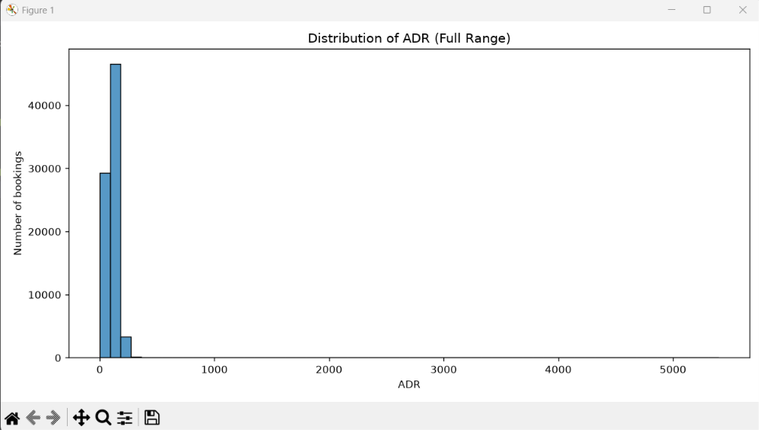
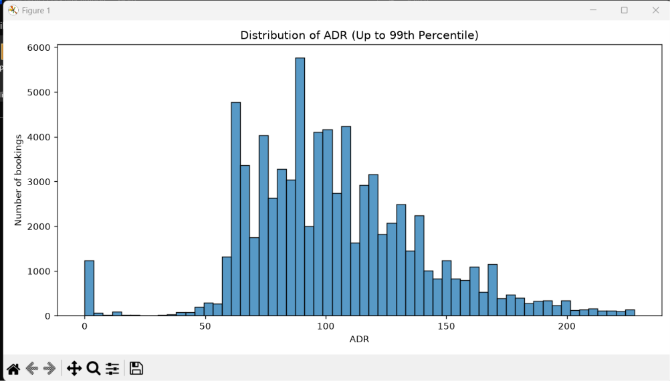
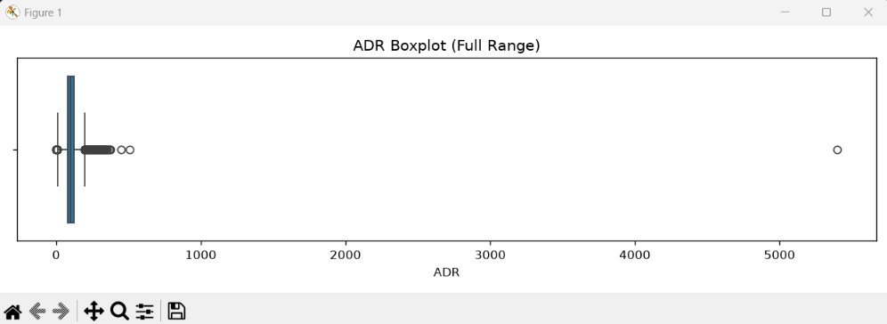
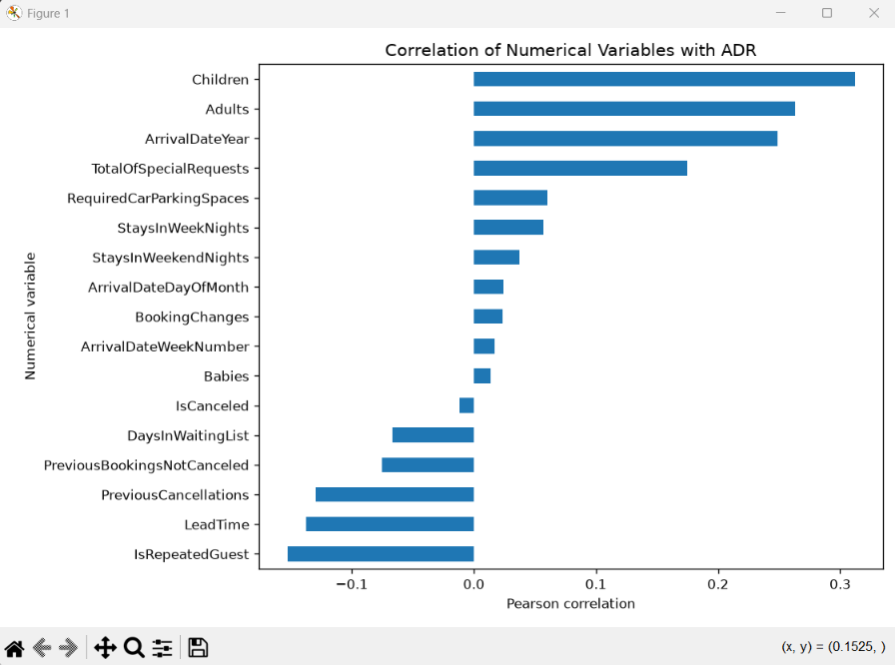
Results:
Dataset shape: (79330, 31)
Missing ADR values: 0

--- ADR Checks ---
ADR values equal to zero: 1208
Negative ADR values: 0

IQR lower bound: 9.000000000000014
IQR upper bound: 196.2
Values below lower bound: 1316
Values above upper bound: 2071

ADR percentiles:
0.00 0.0
0.01 0.0
0.25 79.2
0.50 99.9
0.75 126.0
0.95 175.5
0.99 228.0
1.00 5400.0
Name: ADR, dtype: float64

Rows with the 10 highest ADR values:
ADR Adults Children Babies StaysInWeekendNights StaysInWeekNights ReservedRoomType AssignedRoomType IsCanceled MarketSegment ReservationStatus
5400.00 2 0.0 0 0 1 A A 1 Offline TA/TO Canceled
510.00 1 0.0 0 0 1 A G 0 Offline TA/TO Check-Out
451.50 2 2.0 0 1 1 E E 0 Direct Check-Out
375.50 3 0.0 0 0 2 D D 0 Online TA Check-Out
372.33 3 2.0 0 1 2 G G 0 Direct Check-Out
365.00 2 1.0 0 1 2 A D 0 Offline TA/TO Check-Out
352.50 2 3.0 0 0 1 G G 1 Online TA Canceled
349.63 2 2.0 0 0 3 F F 0 Online TA Check-Out
345.00 3 1.0 0 0 4 G G 0 Direct Check-Out
338.00 2 3.0 0 2 3 G G 0 Direct Check-Out
--- Numerical Correlations with ADR ---
Children 0.311961
Adults 0.262895
ArrivalDateYear 0.248757
TotalOfSpecialRequests 0.174968
RequiredCarParkingSpaces 0.059895
StaysInWeekNights 0.057036
StaysInWeekendNights 0.037020
ArrivalDateDayOfMonth 0.023913
BookingChanges 0.023670
ArrivalDateWeekNumber 0.017194
Babies 0.013697
IsCanceled -0.011965
DaysInWaitingList -0.066639
PreviousBookingsNotCanceled -0.075280
PreviousCancellations -0.129247
LeadTime -0.137240
IsRepeatedGuest -0.152716

--- Minimum Values ---
Adults 0.0
Children 0.0
Babies 0.0
StaysInWeekendNights 0.0
StaysInWeekNights 0.0
LeadTime 0.0
RequiredCarParkingSpaces 0.0
dtype: float64

--- Zero Counts ---
Adults 390
Children 74220
Babies 78961
StaysInWeekendNights 37817
StaysInWeekNights 4963
LeadTime 3109
RequiredCarParkingSpaces 77404
dtype: int64

--- Negative Counts ---
Adults 0
Children 0
Babies 0
StaysInWeekendNights 0
StaysInWeekNights 0
LeadTime 0
RequiredCarParkingSpaces 0
dtype: int64

Bookings with zero adults, children and babies: 167

--- Final EDA Summary ---
Dataset shape: (79330, 31)
Total missing cells: 83800

Columns with missing values:
Company 75641
Agent 8131
Country 24
Children 4
dtype: int64

ADR has potential outliers
Statistic | Result
Q1 (25th percentile) | 79.20
Q3 (75th percentile) | 126.00
IQR | 46.80
Lower IQR bound | 9.00
Upper IQR bound | 196.20
Values above upper bound | 2,071
Values below lower bound | 1,316
Mean | 105.30
Median | 99.90
Min | 0
Max (row 8457) | 5400
Negatives | 0
Zero values | 1208

Duplicates:
Rows involved in exact duplication: 31748
first inspection reported 25,902 duplicated rows, while the EDA output shows 31,748 rows involved in duplicate groups.
These numbers are different because they measure different things:
- df.duplicated().sum() counts repeated occurrences after the first copy.
- df[df.duplicated(keep=False)] includes every row belonging to a duplicated group, including the first copy.
For example, if one row appears four times, the first calculation counts three duplicates, while the second includes all four rows.
Numerical correlations:
Feature | Correlation with ADR | Initial interpretation
Children | +0.312 | More children are associated with higher rates in this dataset.
Adults | +0.263 | Larger adult counts are associated with higher rates.
ArrivalDateYear | +0.249 | Rates may vary across years.
TotalOfSpecialRequests | +0.175 | A modest positive relationship.
IsRepeatedGuest | −0.153 | Repeat guests are associated with somewhat lower rates.
LeadTime | −0.137 | Longer lead times have a modest negative relationship with ADR.
PreviousCancellations | −0.129 | A modest negative relationship.
Correlation measures the strength and direction of a linear relationship. It does not establish causation, and it cannot tell us whether a feature is useful to every model.
Zeroes:
Column | Number of zeros | Initial assessment
Adults | 390 | Investigate; bookings with zero adults may be unusual.
Children | 74,220 | Likely normal; many bookings have no children.
Babies | 78,961 | Likely normal; many bookings have no babies.
StaysInWeekendNights | 37,817 | Normal; some stays don't include weekend nights.
StaysInWeekNights | 4,963 | Investigate whether these are weekend-only stays.
LeadTime | 3,109 | Can be valid; some bookings may be made on the arrival date.
RequiredCarParkingSpaces | 77,404 | Likely normal; most bookings may not require parking.
We need to inspect the 390 rows with zero adults and determine whether their other values make sense. We should also investigate whether the rows with zero weeknight stays are consistent with their arrival dates and weekend stays.
Cleaning:

The ADR value of 5,400
highest-ADR record is:
- ADR: 5400
- Adults: 2
- Stay: 1 weeknight, 0 weekend nights
- Market segment: Offline TA/TO
- Reservation status: Canceled
- Reservation status date: February 19, 2016
- Arrival date: March 25, 2016
This record is particularly suspicious because the booking was canceled, and its ADR is dramatically higher than the rest of the dataset. However, cancellation does not prove that the rate is incorrect.
Decision: flag this record for investigation, but don't delete it yet. We should check the source dataset's documentation or examine whether similar records exist before deciding whether 5,400 is a genuine rate or a data error.
There is also a modeling concern here: ReservationStatus and ReservationStatusDate contain information associated with the eventual booking outcome. If our goal is to predict ADR when a booking is created, these columns should not be used as features because they may contain future information.
Zero ADR and low ADR values
You have:
- 1,208 bookings with ADR equal to zero.
- 1,306 bookings with ADR below 9.
The second group includes the first group, so these counts should not be added together.
Your examples show that some zero-ADR bookings were checked out, while others were canceled. Some have one or more adults and a nonzero stay duration. That means zero ADR is not simply synonymous with cancellation or an empty booking.
Possible explanations include complimentary stays, special arrangements, or data-quality issues. Your current output cannot tell us which explanation applies to each record.
Decision: retain zero ADR and low ADR values for now. We should investigate their frequency and context, then decide whether the regression task is intended to predict the rate for all bookings or only bookings with a positive rate.
Bookings with zero adults
There are 390 such rows. Some have children, and some have neither adults nor children nor babies. Their ADR values range from zero to 200.
These records deserve investigation because a booking with no guests is unusual, but the output alone doesn't establish that all 390 records are invalid.
Decision: don't remove every row with zero adults automatically. First inspect how many have no adults, children, or babies, and whether those rows have valid stay durations and booking statuses.
Company NULL-dominated
Our decision: exclude Company from the initial regression feature set. With 95.35% missingness, it is unlikely to be worth the complexity of recovering useful information from it for our first models. We can revisit this later if there is a compelling reason.
One important distinction: we're excluding the column as a feature, not deleting 75,641 bookings.
Design choice:
Elminate duplicates then drop the null column
Data cleaning:
Issue | decision
Exact duplicate rows | Remove
Company | Drop the column
Remaining missing values | Retain
Negative values in checked columns | None found
ADR = 0 | Retain
ADR = 5,400 | Retain for now
Unusual guest counts | Retain for now
Cleaning 1:
Run cleaning1.py
This version:
- Loads the original Excel file.
- Strips whitespace and converts null-like strings to actual missing values.
- Removes exact duplicate rows, while reporting how many were removed.
- Drops Company because approximately 95.35% of its values are missing.
- Keeps rows with missing Agent, Country, or Children so we don't unnecessarily lose data.
- Checks the resulting dataset without imputing values or removing outliers yet.
Original shape: (79330, 31)

Missing values after normalization:
Company 75641
Agent 8131
Country 24
Children 4
ArrivalDateWeekNumber 0
ArrivalDateMonth 0
IsCanceled 0
StaysInWeekendNights 0
ArrivalDateDayOfMonth 0
Adults 0
dtype: int64

--- Duplicate Removal ---
Duplicate rows when Company is excluded: 31751
Exact duplicate rows removed: 25902
Shape after removing duplicates: (53428, 31)

Company missing percentage: 94.79 %
Shape after dropping Company: (53428, 30)

--- Remaining Missing Values ---
Agent 5587
Country 6
Children 4
dtype: int64
Total remaining missing cells: 5597

--- ADR Summary ---
count 53428.000000
mean 110.985944
std 48.062518
min 0.000000
25% 84.000000
50% 105.300000
75% 134.000000
max 5400.000000
Name: ADR, dtype: float64
Missing ADR values: 0
Negative ADR values: 0
Zero ADR values: 1077

--- Cleaning Summary ---
Original shape: (79330, 31)
Final shape: (53428, 30)
Rows removed: 25902
Columns removed: 1
Remaining exact duplicates: 2 // case where they had different companies so werent removed by removing the duplicates and when the company column was dropped their similarities appeared??
Remaining missing cells: 5597

Saved cleaned dataset to dataset_cleaned1.csv

What should you do next?
Your current script performs initial cleaning, but it does not yet complete model preprocessing.
- Investigate the remaining duplicates.
- Decide whether to retain duplicate rows, based on your findings and the effect on your results.
- Investigate zero and extreme ADR values, including the maximum of 5,400. Do not remove them without justification.
- Handle missing values in Agent, Country, and Children using an appropriate strategy during preprocessing.
- Review potential data leakage. If you want to predict ADR at booking time, ReservationStatus and ReservationStatusDate may contain information unavailable at prediction time.
- Prepare the regression pipeline: select features, encode categorical variables, handle missing values, and establish a baseline model.

Should you remove rows with missing values?
Not automatically. The decision depends on which column is missing and how many rows are affected.
Column | Missing rows after deduplication | Recommended handling
Children | 4 | Impute with the median or a justified value; don't discard rows unnecessarily
Country | 6 | Impute the most frequent category or use an "Unknown" category
Agent | 5,587 | Preserve rows and handle missingness explicitly
Company | 75,641 originally | Drop the entire column because 95.35% is missing

//HLA
Preprocessing
Scenarios and leakage audit
Two scenarios are evaluated, both using the same cleaned dataset (dataset_cleaned1.csv), the same split settings (80/20, random_state=42) and the same models, so the results are comparable.
Scenario 1 (all columns): only the target ADR is removed. X shape: (53428, 29). This scenario includes ReservationStatus, ReservationStatusDate and IsCanceled, which are events that happen only after a booking is made. It is expected to overestimate performance and serves as a reference for the effect of leakage.
Scenario 2 (booking-time): ADR, ReservationStatus, ReservationStatusDate and IsCanceled are removed, because these values cannot be known when the booking is created. X shape: (53428, 26). This is the realistic scenario.
AssignedRoomType is kept in both scenarios because room type strongly affects price. It is assigned by the hotel at or near check-in rather than by the guest, so results should be read as prediction at or shortly after booking.
Workflow: the two scenarios are processed separately, not at the same time. Each one goes through the full flow (feature selection, train/test split, missing values, encoding and scaling, baseline model) and is documented in its own section before the next one begins. The order is Scenario 1 (all columns) first, then Scenario 2 (booking-time). A final section compares the two.

Scenario 1 (all columns)
Step 0: starting point. The input is dataset_cleaned1.csv with shape (53428, 30). Cleaning is finished at this stage, so no further rows are removed. The remaining issues are 2 duplicate rows and missing values in Agent (5,587), Country (6) and Children (4). The data contains 1,077 rows with ADR = 0 and a maximum ADR of 5,400.
Step 1: carried-over decisions.
- Remaining duplicates (2 pairs): retained. They matched on all columns once Company was dropped, but the dataset has no booking ID to confirm they are the same booking, and they are 4 of 53,428 rows (0.007%), so the effect is negligible.
- ADR = 0 (1,077 rows): retained, because they may be complimentary or special-rate stays and are not proven errors.
- ADR = 5,400 (1 row): retained. It is far above the next largest values and may inflate RMSE, so MAE will be reported alongside RMSE.
Step 2: features and target. The target is ADR. Only ADR is removed from the features, so X has shape (53428, 29) and y has shape (53428,). This includes ReservationStatus, ReservationStatusDate and IsCanceled, which are only known after a booking is made, so this scenario is expected to overestimate performance.
Step 3: train/test split. The data is split 80% training and 20% testing with random_state=42. Train shape: (42742, 29). Test shape: (10686, 29). The split is done before any imputation, encoding or scaling so the test data cannot influence those steps.
Step 4a: preparing special columns. Agent is an ID code, not a quantity, so it was converted to text and treated as a category, which prevents the model from reading agent 14 as “greater than” agent 9. ReservationStatusDate was split into three numerical columns (StatusYear, StatusMonth, StatusDay) and the original column was removed. These conversions work row by row and learn nothing from the data, so they cannot leak information from the test set. The arrival date was already stored in separate columns (year, month, week number, day), and these were kept separate so the model can learn the long-term trend (year) and the seasonal pattern (month) independently.
Feature engineering. Two columns were created from existing ones: TotalNights (StaysInWeekendNights + StaysInWeekNights) and TotalGuests (Adults + Children + Babies). ADR is a rate per night and depends on the length of the stay and the number of guests, which the raw data spreads across several columns, so the totals give the model this information directly. A missing Children value (4 rows) is counted as 0 in TotalGuests. The original columns are kept, so the model receives both the originals and the totals, and the new features are linearly dependent on them, which can make individual coefficients of a linear model harder to interpret. Their effect on performance will be assessed in the baseline comparison.These conversions work row by row and learn nothing from the data, so they cannot leak information from the test set. After this step the data has 33 columns.
Column types. The columns were separated by data type into 11 categorical columns (ArrivalDateMonth, Meal, Country, MarketSegment, DistributionChannel, ReservedRoomType, AssignedRoomType, DepositType, Agent, CustomerType, ReservationStatus) and 22 numerical columns (the original 20, plus TotalNights and TotalGuests).
Step 4b: missing values. Rows with missing values are not removed. Children (4 missing) is filled with the median of the training data. Country (6 missing) is filled with the category “Missing”. Agent (5,587 missing, 10.5% of rows) is treated as a categorical ID and its missing values become the category “Missing”, so no rows are lost. All imputation values are learned from the training set only.
Pipeline treatment by column type.
Column type | What the pipeline does
Numerical (22 columns) | Fill missing values with the median, then scale with StandardScaler
Categorical (11 columns) | Fill missing values with “Missing”, then one-hot encode

Step 5: encoding and scaling. The 22 numerical columns are scaled with StandardScaler. The 11 categorical columns are one-hot encoded, with categories of fewer than 20 rows grouped together. The pipeline is fitted on the training set (fit_transform), which learns the medians, means, standard deviations and category lists from the training rows. The test set is then transformed (transform) with these learned values without refitting, so no information from the test data influences the preprocessing. After preprocessing, the training matrix has shape (42742, 203) and the test matrix has shape (10686, 203).
Effect of one-hot encoding. After preparation the data had 33 columns, which increased to 203 after preprocessing. The 22 numerical columns remain unchanged in number, while the 11 categorical columns expanded into 181 binary (0/1) columns, one per category. Columns with many categories, mainly Country and Agent, account for most of this growth. Rare categories (fewer than 20 rows) were grouped to limit it.

Scenario 2 (booking-time)
Scenario 2 follows the same flow as Scenario 1, using the same cleaned dataset, split settings and pipeline. Only the feature selection differs.
Step 0: starting point. Same as Scenario 1: dataset_cleaned1.csv, shape (53428, 30), with 2 duplicate rows and missing values in Agent (5,587), Country (6) and Children (4). The data contains 1,077 rows with ADR = 0 and a maximum ADR of 5,400. The carried-over decisions on duplicates, ADR = 0 and ADR = 5,400 are the same as in Scenario 1.
Step 2: features and target. The target is ADR. ADR, ReservationStatus, ReservationStatusDate and IsCanceled are removed, because these values are outcomes that cannot be known when the booking is created. X has shape (53428, 26) and y has shape (53428,). This is the realistic scenario.
Step 3: train/test split. The data is split 80% training and 20% testing with random_state=42, giving the same rows as Scenario 1: train (42742, 26) and test (10686, 26). The same split keeps the comparison between the scenarios fair. The split is done before any imputation, encoding, scaling or feature engineering, so the test data cannot influence those steps.
Step 4a: preparing special columns. Agent is an ID code, not a quantity, so it was converted to text and treated as a category. No date conversion is needed, because ReservationStatusDate was removed. The arrival date columns remain separate (year, month, week number, day), so the model can learn the long-term trend and the seasonal pattern independently.
Feature engineering. The same two columns as in Scenario 1 were created: TotalNights (StaysInWeekendNights + StaysInWeekNights) and TotalGuests (Adults + Children + Babies). A missing Children value (4 rows) is counted as 0 in TotalGuests. The original columns are kept, and the model receives both the originals and the totals. These conversions work row by row and learn nothing from the data, so they cannot leak information from the test set. After this step the data has 28 columns.
Column types. The columns were separated by data type into 10 categorical columns (ArrivalDateMonth, Meal, Country, MarketSegment, DistributionChannel, ReservedRoomType, AssignedRoomType, DepositType, Agent, CustomerType) and 18 numerical columns (the 16 original numerical columns, plus TotalNights and TotalGuests).
Step 4b: missing values. Same as Scenario 1: Children is filled with the training median, and Country and Agent missing values become the category “Missing”. No rows are removed, and all values are learned from the training set only.
Pipeline treatment by column type.
Column type | What the pipeline does
Numerical (18 columns) | Fill missing values with the median, then scale with StandardScaler
Categorical (10 columns) | Fill missing values with “Missing”, then one-hot encode
Step 5: encoding and scaling. The 18 numerical columns are scaled with StandardScaler, and the 10 categorical columns are one-hot encoded, with categories of fewer than 20 rows grouped together. The pipeline is fitted on the training set (fit_transform) and applied to the test set (transform) without refitting. After preprocessing, the training matrix has shape (42742, 196) and the test matrix has shape (10686, 196).
Effect of one-hot encoding. After preparation the data had 28 columns, which increased to 196 after preprocessing. The 18 numerical columns remain unchanged in number, while the 10 categorical columns expanded into 178 binary (0/1) columns.
--STARTING THE BASELINE
- Dummy regression
The Dummy Regressor with the mean strategy was implemented as the initial baseline for both preprocessing scenarios.
The model achieved a Mean Absolute Error (MAE) of 32.0971, a Root Mean Squared Error (RMSE) of 42.5402, and an R² score of approximately 0.
Both scenarios produced identical results because the Dummy Regressor ignores input features and predicts the mean ADR calculated from the training data for every test sample.
These results establish a reference performance level for evaluating more advanced regression models. Future models should aim to achieve lower MAE and RMSE values and a higher R² score.
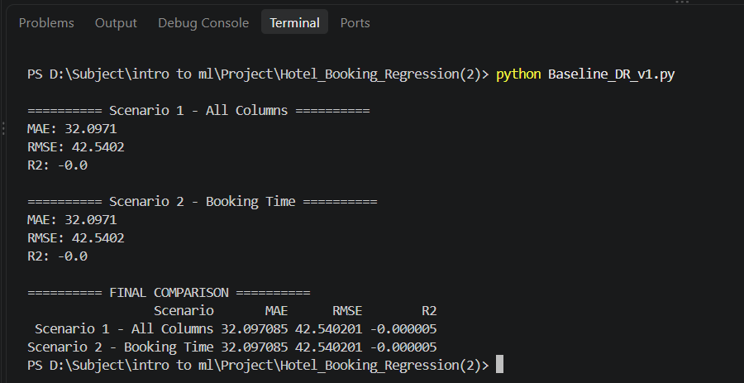

- Linear regression
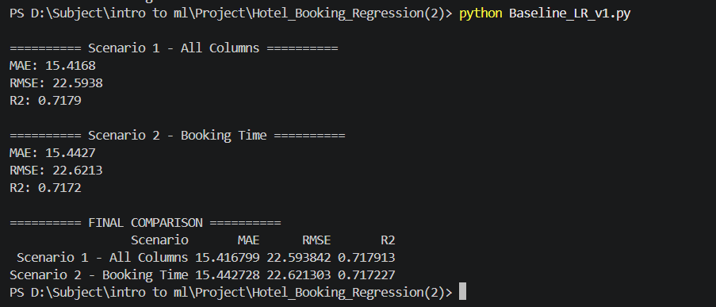
Objective
After establishing the initial baseline using Dummy Regression, Linear Regression was implemented as the first actual predictive model for the hotel booking dataset.
The main objective is to predict the Average Daily Rate (ADR) using the available booking-related features.
Unlike Dummy Regression, which predicts the same average ADR for every booking, Linear Regression learns relationships between the input features and the target variable to generate predictions based on booking characteristics.
The model was evaluated using two different preprocessing scenarios to investigate the effect of including or excluding post-booking information.
Model Description
Linear Regression is a supervised machine learning algorithm used to predict continuous numerical values.
It attempts to establish a linear relationship between independent variables (features) and a dependent variable (target).
In this project:
Independent variables (X): Booking-related information, such as lead time, number of guests, length of stay, customer type, market segment, and other available features.
Dependent variable (y): ADR (Average Daily Rate).
The model learns coefficients for the input features during training. These coefficients represent the contribution of each feature to the predicted ADR.
The general equation of Linear Regression is:
ŷ = β₀ + β₁X₁ + β₂X₂ + ... + βₙXₙ
Where: ŷ: Predicted ADR.
β₀: Intercept (constant term).
β₁, β₂, ..., βₙ: Model coefficients.
X₁, X₂, ..., Xₙ: Input features.
The model estimates the coefficients by minimizing the sum of squared differences between actual and predicted values (Ordinary Least Squares).
Experimental Setup
The model was trained and evaluated using the two preprocessed datasets generated in the previous preprocessing stage.
Both scenarios used the same training and testing split to ensure a fair comparison.
Dataset splitting:
Training data: 80%.
Testing data: 20%.
Random state: 42.

Input preparation:
The data was already preprocessed before training, including:
Handling missing numerical and categorical values.
Converting categorical variables into numerical representations using One-Hot Encoding.
Scaling numerical features using StandardScaler.
Applying feature engineering to create additional features, such as TotalNights and TotalGuests.
No additional preprocessing or data splitting was performed during model training.

Preprocessing Scenarios
Two scenarios were evaluated:
Scenario 1 – All Columns
This scenario uses all available features except ADR, including columns that contain information recorded after the booking process.
The objective is to investigate the predictive performance when all available information is included.
Scenario 2 – Booking Time
This scenario excludes the following columns: ReservationStatus
ReservationStatusDate
IsCanceled
These columns were removed because they contain information associated with events or decisions occurring after the initial booking.
The objective is to evaluate the model using information that would be more realistically available when a customer makes a reservation.

Model Implementation
The Linear Regression model was implemented using Scikit-learn:
LinearRegression()
The implementation follows these steps:
Load the preprocessed training and testing datasets from the saved NPZ files.
Initialize the Linear Regression model.
Train the model using the training features and target values.
Generate ADR predictions using the testing features.
Evaluate the predictions using MAE, RMSE, and R².
The same implementation was applied to both preprocessing scenarios to maintain consistency.

Evaluation Metrics
Three evaluation metrics were used to measure the model's performance.
Mean Absolute Error (MAE)
Measures the average absolute difference between actual ADR values and predicted ADR values.
A lower MAE indicates that the model's predictions are closer to the actual values.
Root Mean Squared Error (RMSE)
Measures the square root of the average squared prediction errors.
RMSE gives greater weight to larger prediction errors, making it useful for identifying models that produce some significantly inaccurate predictions.
A lower RMSE indicates better predictive performance.
R² Score (Coefficient of Determination)
Measures how much of the variation in the target variable (ADR) is explained by the model.
R² = 1: Perfect predictions.
R² = 0: The model performs approximately like predicting the test-set mean.
R² < 0: The model performs worse than predicting the test-set mean.
A higher R² generally indicates better predictive performance.

Experimental Results
After training and evaluating the Linear Regression model, the following results were obtained:
Evaluation Metric | Scenario 1 – All Columns | Scenario 2 – Booking Time
MAE | 15.4168 | 15.4427
RMSE | 22.5938 | 22.6213
R² | 0.7179 | 0.7172
Scenario 1 Results
The model achieved:
MAE = 15.4168
RMSE = 22.5938
R² = 0.7179
The R² score indicates that the model explains approximately 71.79% of the variation in ADR within the testing dataset.
The MAE indicates that the model's predictions differ from actual ADR values by approximately 15.42 units on average.

Scenario 2 Results
The model achieved:
MAE = 15.4427
RMSE = 22.6213
R² = 0.7172
The model explains approximately 71.72% of the variation in ADR within the testing dataset.
Despite removing the post-booking columns, the model maintained almost the same predictive performance as Scenario 1.

Comparison Between the Two Scenarios
The results show that Scenario 1 performs slightly better than Scenario 2 across all three evaluation metrics.
However, the differences are very small:
MAE difference: 0.0259.
RMSE difference: 0.0275.
R² difference: 0.0007.
This indicates that removing the post-booking features had very little effect on Linear Regression performance.
An important observation is that the booking-time features already contain sufficient predictive information for the model to achieve a relatively strong result.
Although Scenario 1 achieved marginally better metrics, Scenario 2 is more appropriate for a realistic hotel booking price prediction system because it does not depend on information that becomes available after the reservation process.

Comparison with Dummy Regression
Linear Regression was also compared with the initial Dummy Regression baseline.
The Dummy Regressor used the mean strategy, predicting the average ADR from the training dataset for every testing sample.
The comparison is presented below:
Metric | Dummy Regression | Linear Regression (Scenario 1) | Linear Regression (Scenario 2)
MAE | 32.0971 | 15.4168 | 15.4427
RMSE | 42.5402 | 22.5938 | 22.6213
R² | -0.000005 | 0.7179 | 0.7172
Performance Improvement
Compared with Dummy Regression:
Scenario 1:
MAE decreased by approximately 51.97%.
RMSE decreased by approximately 46.89%.
R² increased to 0.7179.

Scenario 2:
MAE decreased by approximately 51.89%.
RMSE decreased by approximately 46.82%.
R² increased to 0.7172.
These improvements demonstrate that using booking-related features provides substantially better predictions than simply predicting the average ADR.

Discussion
The experimental results demonstrate that Linear Regression provides a considerably stronger baseline than Dummy Regression.
The model successfully learned relationships between the available booking features and ADR, achieving an R² score above 0.71 in both scenarios.
Another important finding is that removing post-booking information resulted in only a negligible decrease in predictive performance.
This suggests that the features available at booking time contain most of the information needed by Linear Regression to estimate ADR.
However, Linear Regression assumes that the target variable has a linear relationship with the input features. Real-world hotel pricing may involve more complex and non-linear relationships that this model cannot fully capture.
Therefore, more advanced regression algorithms will be investigated in subsequent experiments to determine whether they can improve prediction performance.
Conclusion
Linear Regression was successfully implemented and evaluated using both preprocessing scenarios.
The model achieved an MAE of 15.4168 and an R² score of 0.7179 in Scenario 1, while Scenario 2 achieved an MAE of 15.4427 and an R² score of 0.7172.
Both scenarios significantly outperformed the Dummy Regression baseline, demonstrating the importance of using booking-related features when predicting ADR.
Scenario 2 is considered the more realistic experimental setting because it relies only on information available at booking time.
Overall, Linear Regression establishes a strong initial predictive baseline for the regression task. Its results will serve as a reference for evaluating more advanced regression models in the next stages of the project.

Steps genereally: Once we've resolved the data-quality questions, our next steps will be:
- Apply justified cleaning rules and document them.
- Define the prediction point and audit potential leakage columns.
- Split the data into training and test sets.
- Build a preprocessing pipeline for missing values and categorical variables.
- Establish a baseline regression model.
Issue | Initial decision | Reason
Company | Exclude as a feature | 95.35% missing or null-like
Country | Keep; impute missing values later | Only 24 missing values
Children | Keep; impute missing values later | Only 4 missing values
Exact duplicates | Remove exact duplicate rows for the initial experiment, and document this decision | Avoid giving repeated identical rows extra weight
ADR = 0 | Keep for now | Could represent legitimate complimentary or special-rate stays
ADR = 5,400 | Investigate; don't automatically delete | Extreme, but not proven erroneous
Zero adults | Investigate; don't automatically delete | Unusual, but not enough evidence to discard
ReservationStatus, ReservationStatusDate | Exclude from booking-time prediction features | Potential leakage from future booking outcomes

